

Part A: Browser Forensics
For browser forensic : I have Microsoft Edge in my virtual machine :
Browser Locations and Extraction
Browser | Profile Path | Key Artifact files
Microsoft Edge | %localappdata%\Microsoft\Edge\User Data\Default | Cache , Extension , Web Data , History

Browsing History
To review the browser history first Download the DB Browser for SQLite —> Install it
And open the History of Edge in it. And navigate to the Browser Data 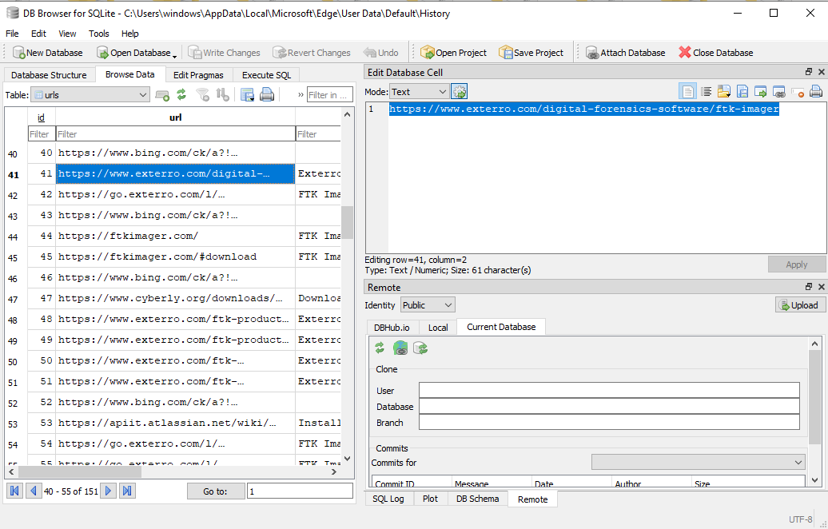
In tables option select urls : This will show the URLs, page titles, and visit counts.
Again select the visits : To see the exact timestamps.
Analyze Download History
Downloading History is very important in forensic Investigation.
Switch the table view to downloads.
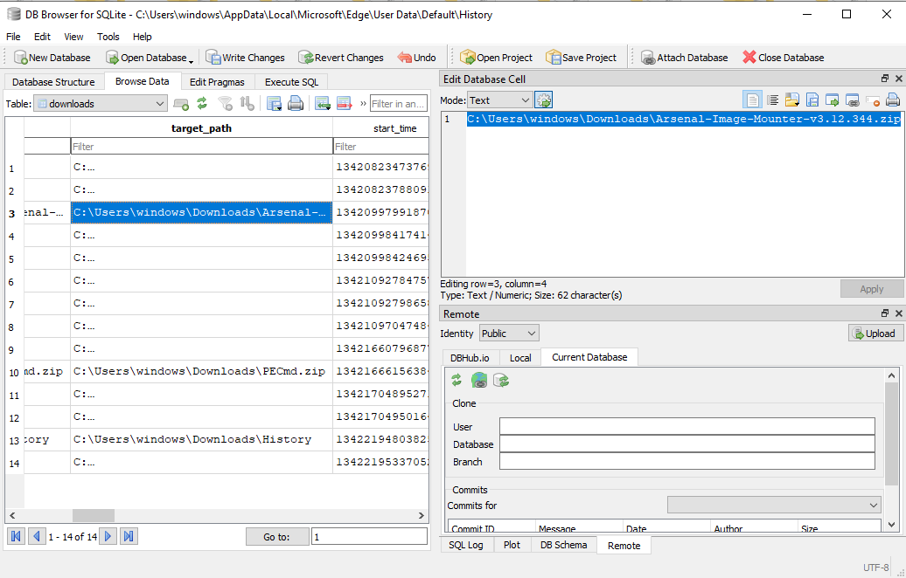
The time is in non-readable format. So , you need to change it in readable format
Navigate to Execute SQL and past the following command and run
SELECT datetime(start_time / 1000000 + (strftime('%s', '1601-01-01')), 'unixepoch', 'localtime') AS readable_time, * FROM downloads;
Document the following fields:
- target_path: C:\Users\windows\Downloads\PECmd.zip
- referrer: https://ericzimmerman.github.io/
- total_bytes: 4061963
- start_time: 2026-04-26 13:35:56
Extract the Data
Go to File -> Export -> Table(s) as CSV file...
Select urls, visits, and downloads.
Save these files to the working folder. We will use these to create a "Unified Timeline."

Forensic Investigation

Timestamp (Human Readable) | Activity Type | Page Title / File Name | URL / Path
2026-05-02 14:10:22 | Web Visit | DB Browser for SQLite | https://sqlitebrowser.org/dl/
2026-05-02 14:15:45 | Web Visit | Google drive | https://drive.google.com/drive/folders
2026-05-02 14:16:10 | Download | DB.Browser.for.SQLite-v3.13.1-win64.msi | C:\Users\windows\Downloads
Cookie & Session Data Analysis
Upon examination of the Cookies SQLite database, no active cookie records were found. This indicates either that the browser was recently cleared of session data, or the user is browsing in a mode that does not persist cookies to the disk.
Cache Examination
For cache Examination the required tool is ChromeCacheView
Download and run ChromeCacheView.
Go to File -> Select Cache Folder.
Paste the path of Edge cache
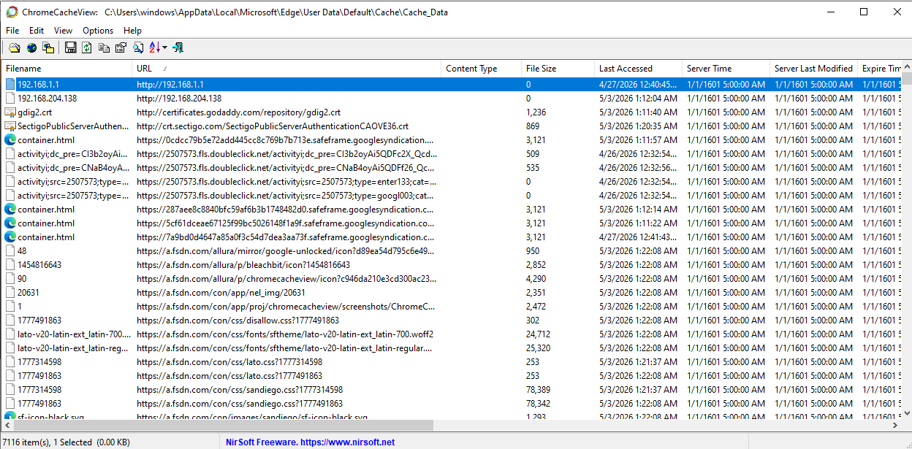
The cache analysis of Microsoft Edge revealed 7,116 stored items. Notable findings include access to local network gateways (192.168.1.1) and forensic tool repositories (fsdn.com). The presence of these files confirms active browsing between April 26 and May 3, 2026. Because these files remain in the cache after history is deleted, they serve as a secondary source of truth for user activity.
Extensions
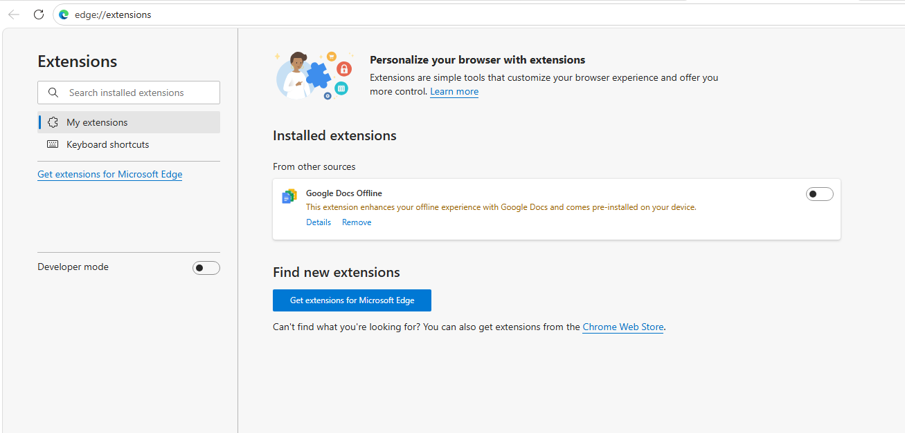
An audit of the Microsoft Edge extensions was conducted via edge://extensions and the Secure Preferences file. No third-party extensions were identified. This suggests the browser environment is in its default state, minimizing the risk of unauthorized data access or credential harvesting by malicious browser add-ons.

Part B: LNK File Analysis
Locating and Extracting LNK Files
To capture that which application can be used at the end or last time navigate to the Recent Folder :
Location | TypePathForensic | Significance
Recent Items | %AppData%\Microsoft\Windows\Recent | Shows the most recent files manually opened by the user.
Desktop | C:\Users\windows\Desktop | Contains persistent shortcuts to frequently used applications or folders.
Parsing with LECmd
LECmd (LNK Explorer Command Line) is the industry standard for this task.
LECmd.exe -d C:\Users\windows\Desktop\LNK_Evidence_collection --csv C:\Users\windows\Desktop\LNK_Evidence_Output
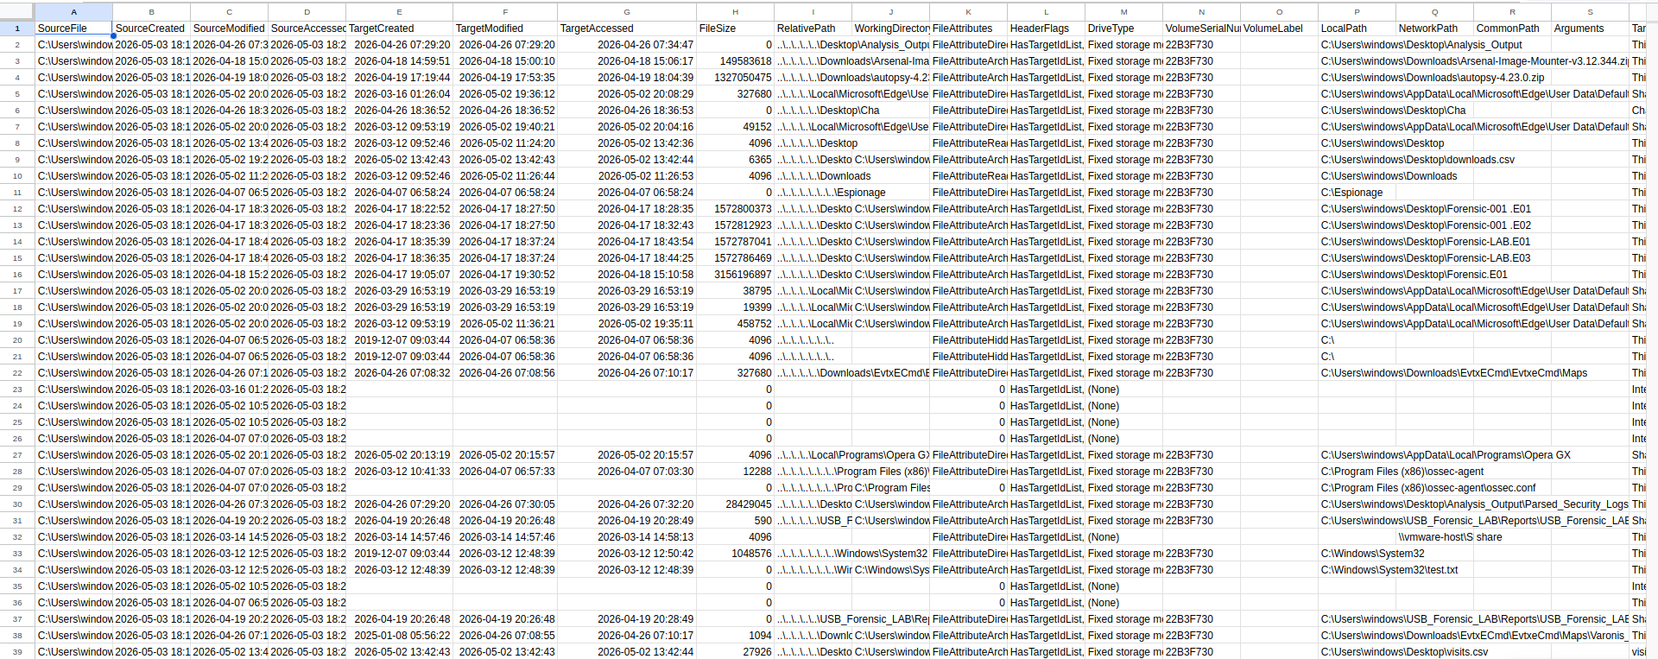
Identifying USB Devices
USB and Removable Media Identification
Volume Serial Number: All entries in your current view show a Volume Serial Number of 22B3F730.
Drive Type: These are all marked as Fixed storage media.
Finding: All 40 parsed LNK entries correspond to the Volume Serial Number 22B3F730 and are categorized as Fixed storage media. This indicates that no files were accessed directly from a removable USB drive during the timeframe captured by these artifacts.

2. Network Share Access
- Network Path Identified: Look at row 25 (SourceFile vmaware-host\S share).
- Finding: Entry with a NetworkPath: \\vmware-host\S share.
- Investigative Significance: The analysis identified a network connection to \\vmware-host\S share. The LNK file share (2).lnk confirms that a shared directory between the host and the virtual machine was accessed on March 14, 2026. This is investigatively significant as it represents a potential vector for file transfer into the isolated VM environment.

3. File Access Patterns
- TargetAccessed: Sort CSV by Column G (TargetAccessed)
- Patterns: A cluster of activity was observed on May 2, 2026, between 13:42 and 20:28. During this window, the user accessed forensic tools (Autopsy, Arsenal Image Mounter) and laboratory reports. This pattern indicates a focused forensic examination session rather than random system use.
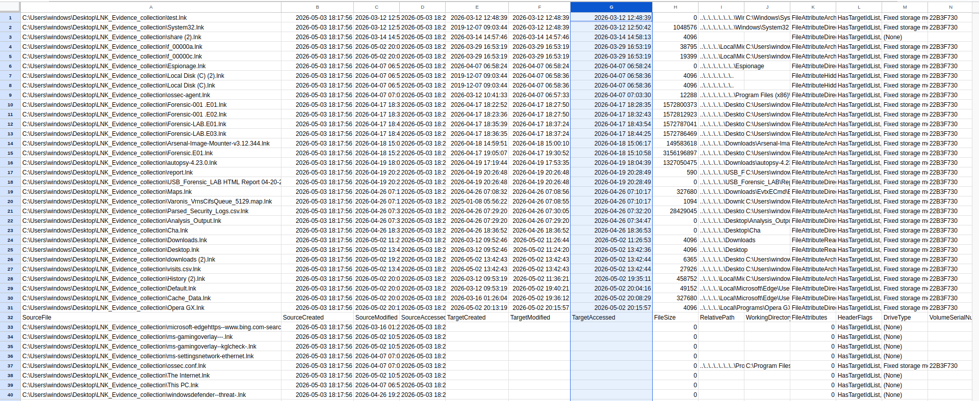

Structured Report :
Section | Content to Include
Collection Methodology | Mention copying 40 LNK files from %AppData%\Microsoft\Windows\Recent and parsing them with LECmd.
USB Inventory | State that all files were found on the fixed volume 22B3F730. Mention that no external USB serial numbers were detected.
Network Activity | Document the server name (vmware-host) and the share path (\S share).
Timeline Analysis | Use your sorted CSV to list the most recent 10 files accessed. Flag the files that no longer exist (0-byte entries).

Part C: Phase 2 Artifact Integration Exercise
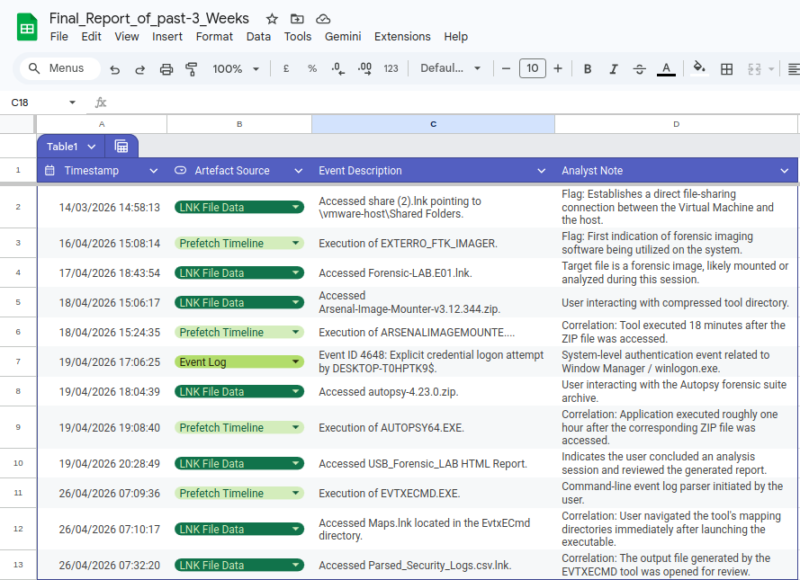
Conclusion
The unified artifact picture confirms that DESKTOP-T0HPTK9 is a securely operated forensic workstation. The activity directly aligns with a user performing structured laboratory exercises involving USB forensics and event log parsing. If this were a real-world investigation, the immediate next step would be to ingest the Microsoft Edge browser history and downloads.csv artifacts into this timeline to bridge the gap between web acquisition and local execution.

